Jenkins-02

1.Configure 2 slave machines in the Jenkins master.
prepare two agent machines
agent-1
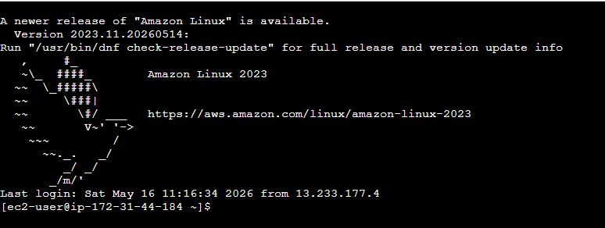
Agent-2
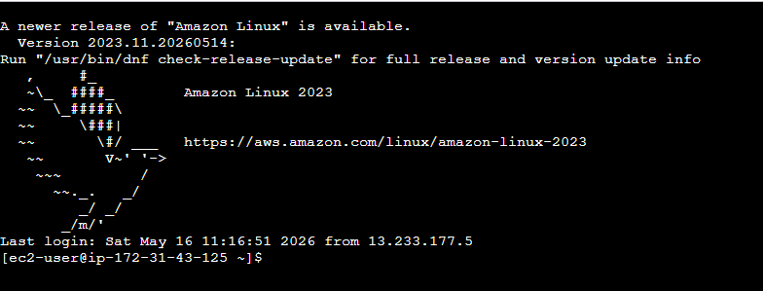
Install java on both agent servers
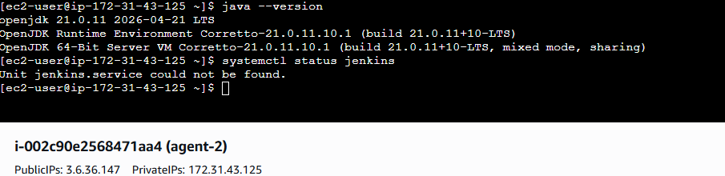
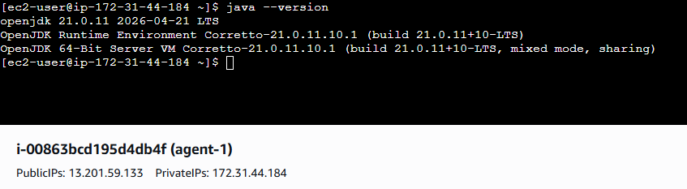
Create jenkins user (Jenkins agent will run as this user) on both agent server
useradd -m -s /bin/bash jenkins
Create .ssh directory for jenkins userc on both agent servers
mkdir -p /home/jenkins/.ssh
chown jenkins:jenkins /home/jenkins/.ssh
chmod 700 /home/jenkins/.ssh

Prepare the Jenkins Controller (Master)
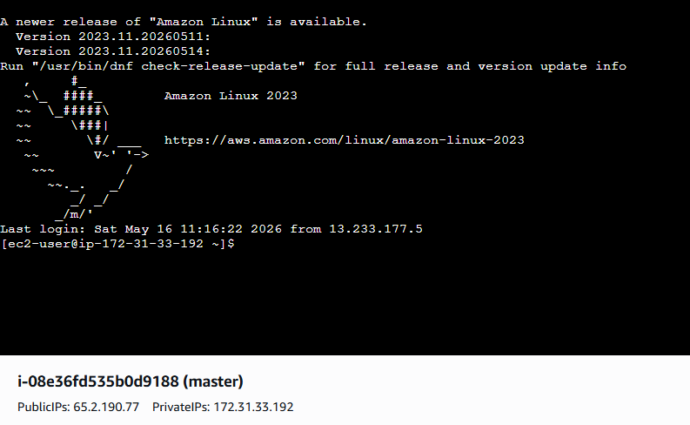

Ensure the 'jenkins' user exists
This command checks and creates it only if missing
id -u jenkins &>/dev/null || useradd -m -s /bin/bash -d /var/lib/jenkins jenkins
passwd jenkins
sudo usermod -s /bin/bash Jenkins

Create .ssh directory for the jenkins user (with correct permissions)
mkdir -p /var/lib/jenkins/.ssh
chown jenkins:jenkins /var/lib/jenkins/.ssh
chmod 700 /var/lib/jenkins/.ssh

Generate SSH Key Pair on Controller

Switch to jenkins user
su - jenkins

# Navigate to .ssh directory
cd ~/.ssh || mkdir ~/.ssh && cd ~/.ssh

# Generate RSA key pair (4096 bits, no passphrase)
ssh-keygen -t rsa -b 4096 -f id_rsa -q -N ""

# Set correct permissions
chmod 600 id_rsa
chmod 644 id_rsa.pub

# Display the public key (you will need it for agents)
cat /var/lib/jenkins/.ssh/id_rsa.pub

Copy the Public Key to Both Agents

Add the master's public key (paste the key you copied!)
echo "ssh-rsa AAAAB3NzaC1yc2E... jenkins@master" >> //jenkins/.ssh/authorized_keys
chown jenkins:jenkins /home/jenkins/.ssh/authorized_keys
chmod 600 /home/jenkins/.ssh/authorized_keys

Add Agents' Host Keys to known_hosts (Avoid Host Key Verification Prompts)

ssh-keyscan -H <agent-1-ip-or-hostname> >> /var/lib/jenkins/.ssh/known_hosts
ssh-keyscan -H <agent-2-ip-or-hostname> >> /var/lib/jenkins/.ssh/known_hosts
Fix ownership and permissions
chown jenkins:jenkins /var/lib/jenkins/.ssh/known_hosts
chmod 600 /var/lib/jenkins/.ssh/known_hosts

Open Jenkins in browser
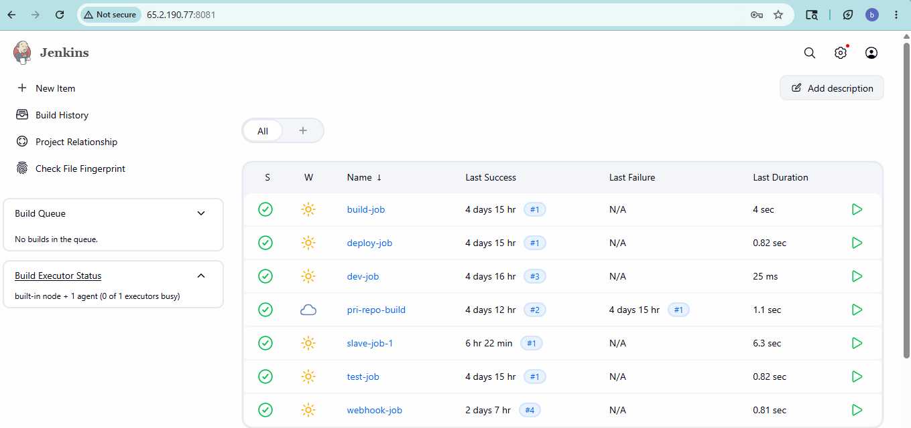
Go to **Manage Jenkins → Nodes and Clouds → New Node
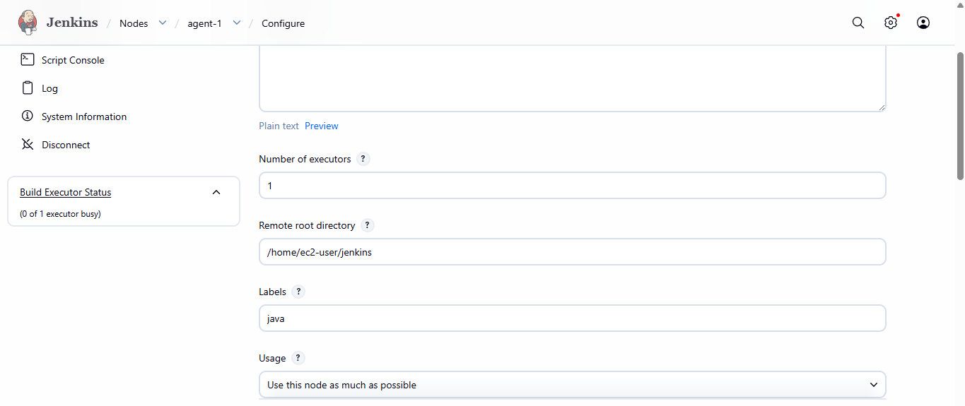
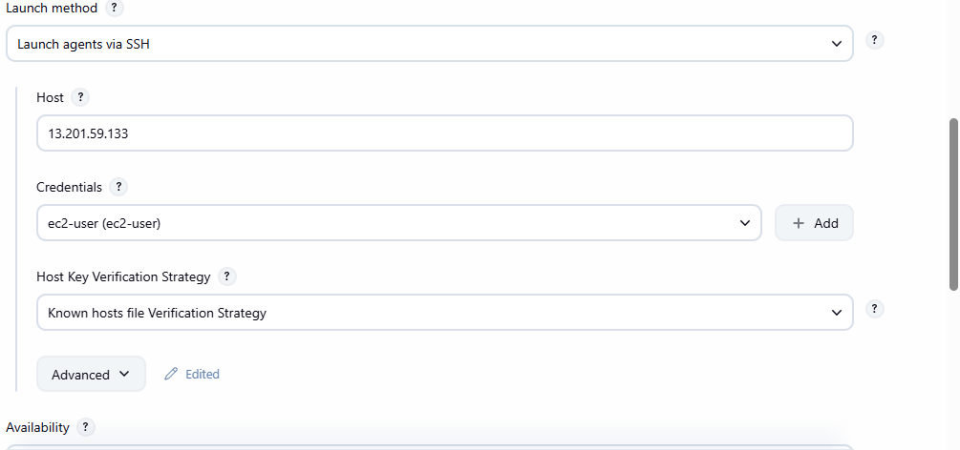
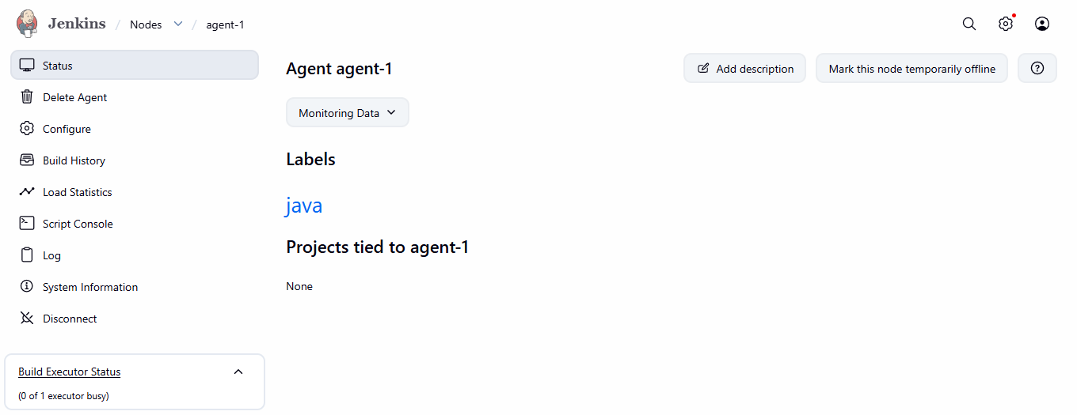

Create new itemconfigure jobadd lebel(agent node-1)build jobcheck the console output

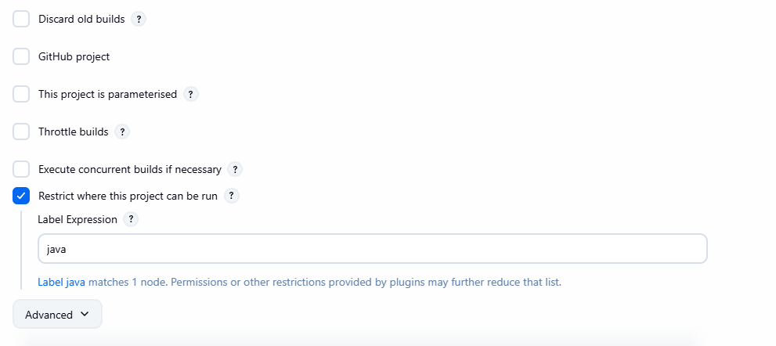
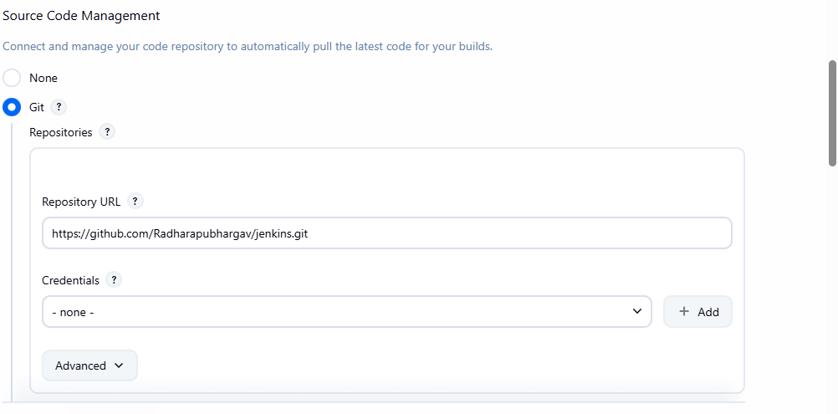
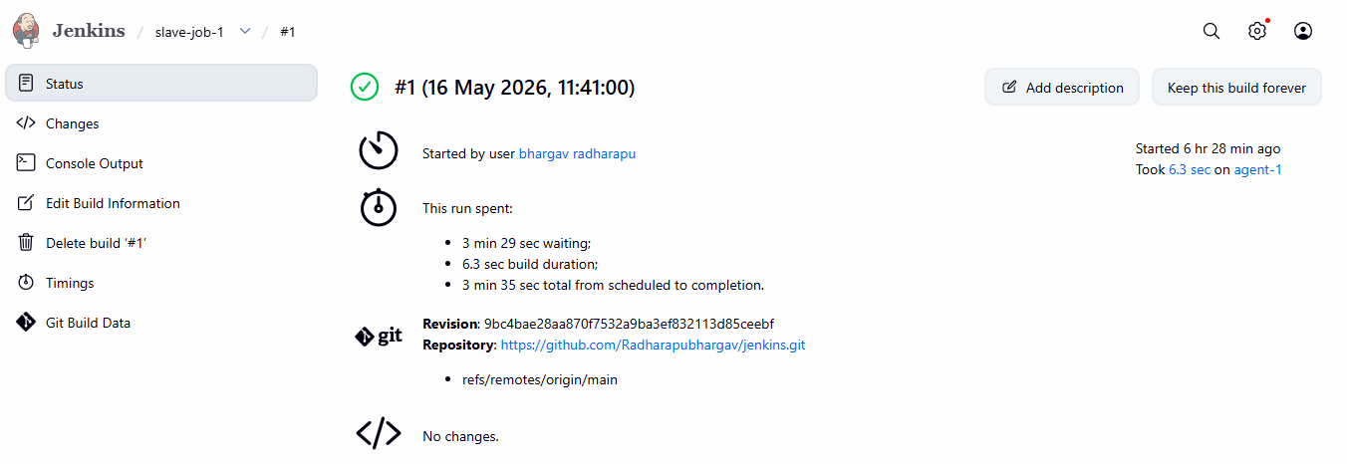
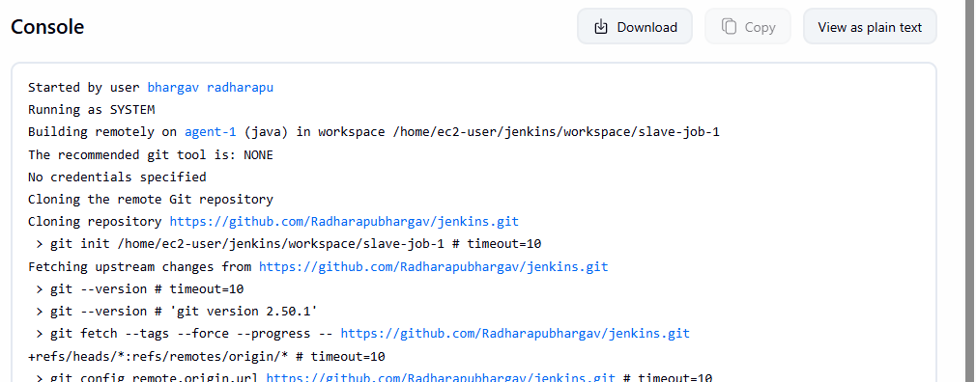

- Configure webhooks to the Jenkins job.
Install GitHub Plugin in Jenkins
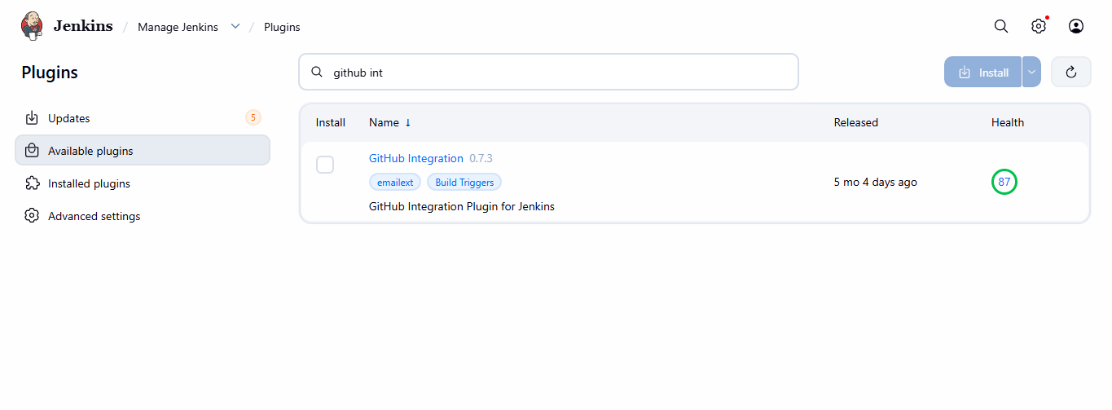
Create Jenkins job
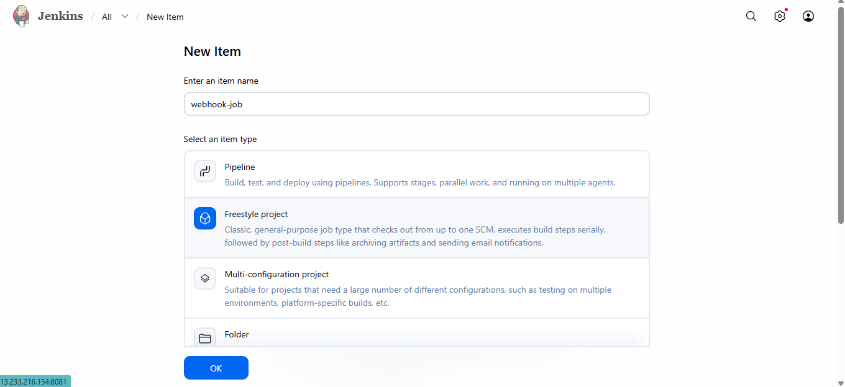

Configure GitHub Webhook
Repository → Settings → WebhooksAdd webhook
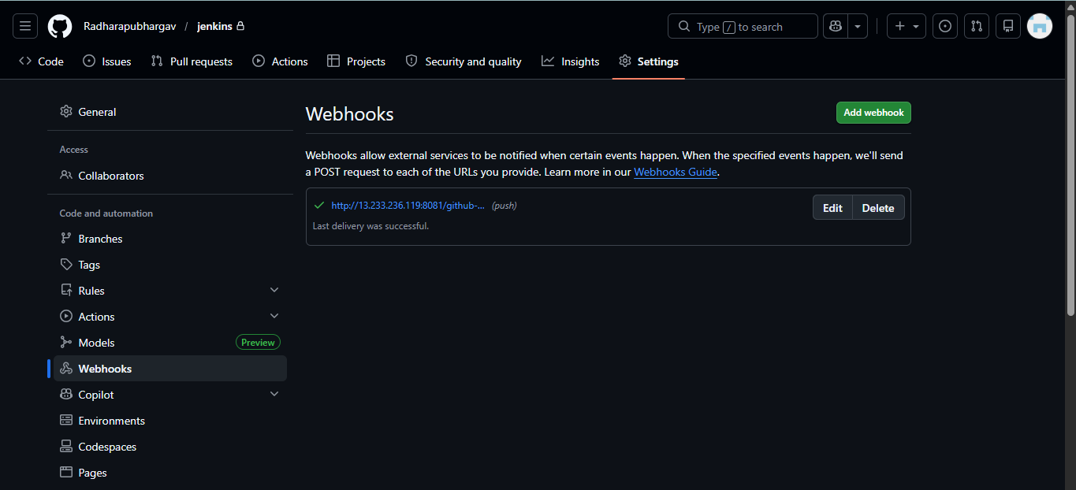
Configure Git Repository in Jenkins
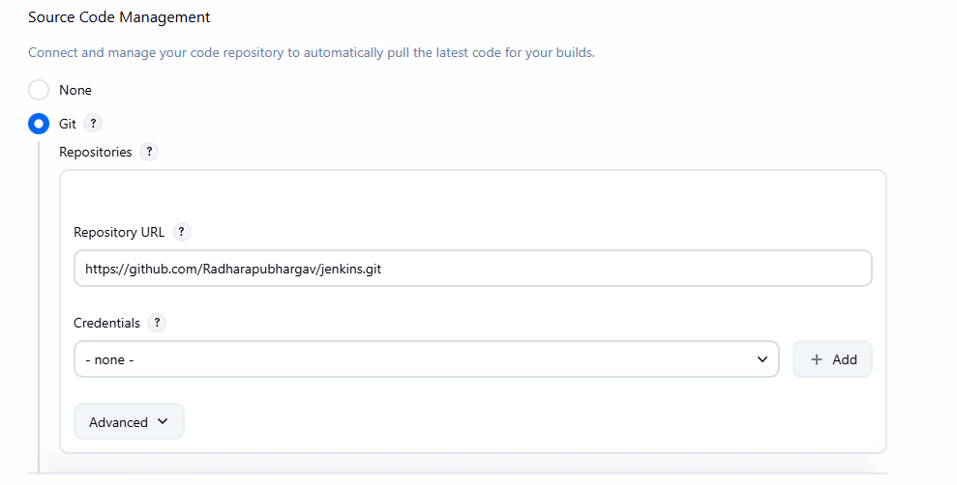
Configure Build Triggerselect GitHub hook trigger for GITScm pollingsave job
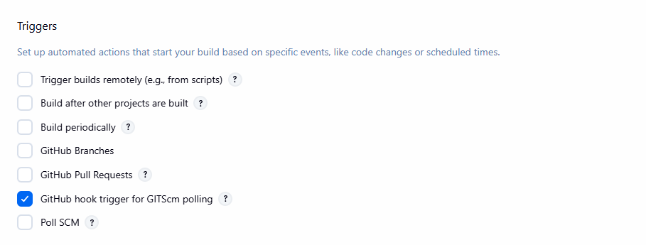
Test Webhook
Make a small change in your repository
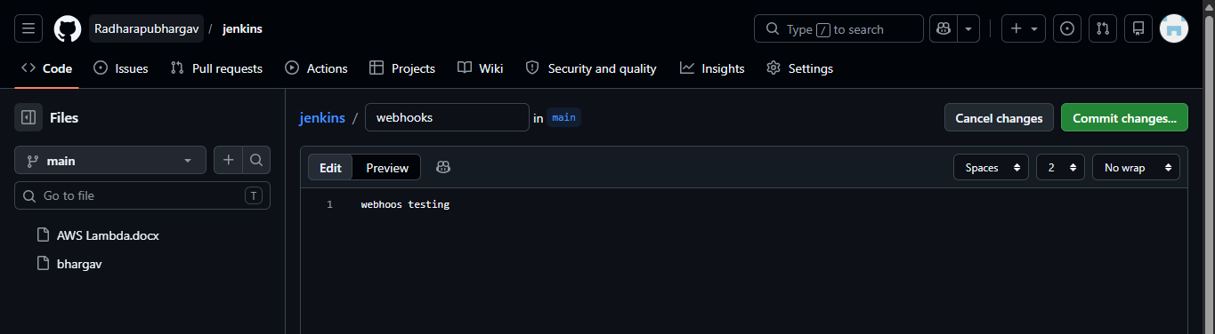
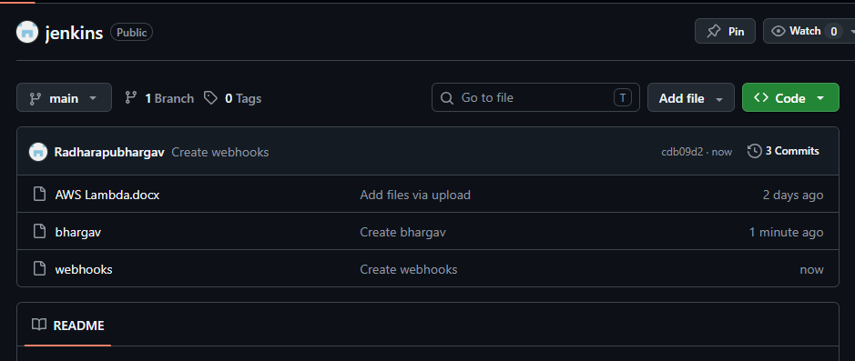

Verify Jenkins Build
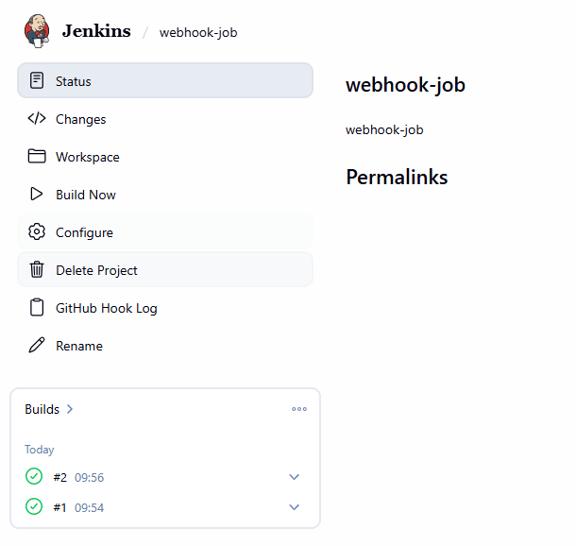
Verify console output
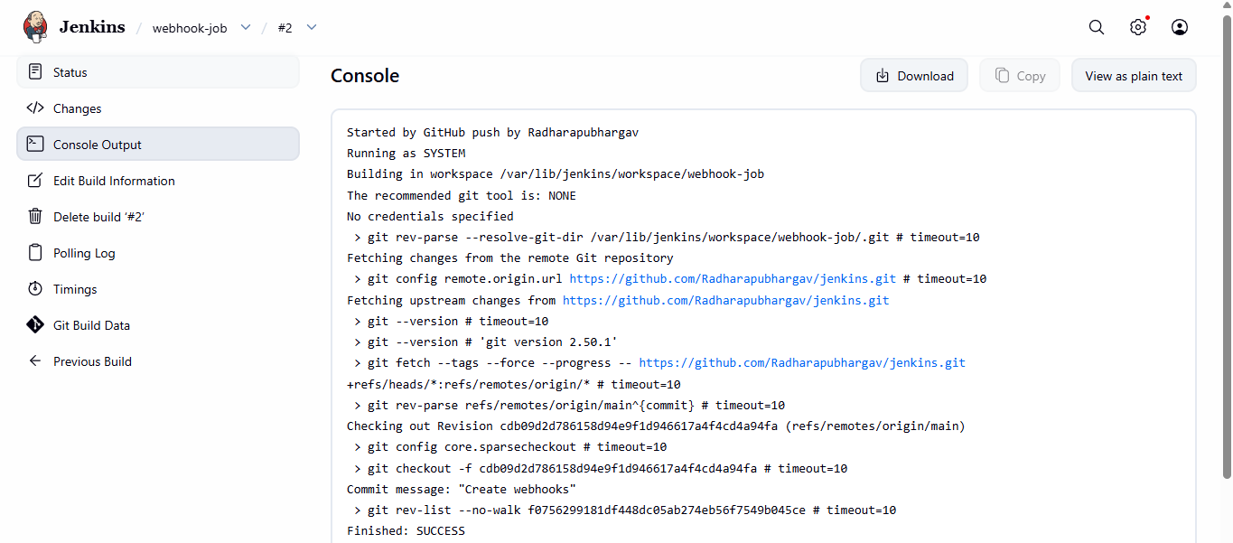
- ConfigurePoll SCMandBuild Periodicallyoptions in the Jenkins job.

What is Poll SCM?
Poll SCM checks the Git repository at scheduled intervals.
- If Jenkins detects code changes → build starts
- If no changes → no build

What is Build Periodically?
Build Periodically runs builds on a fixed schedule.
- Runs even if there are no code changes
create a new job
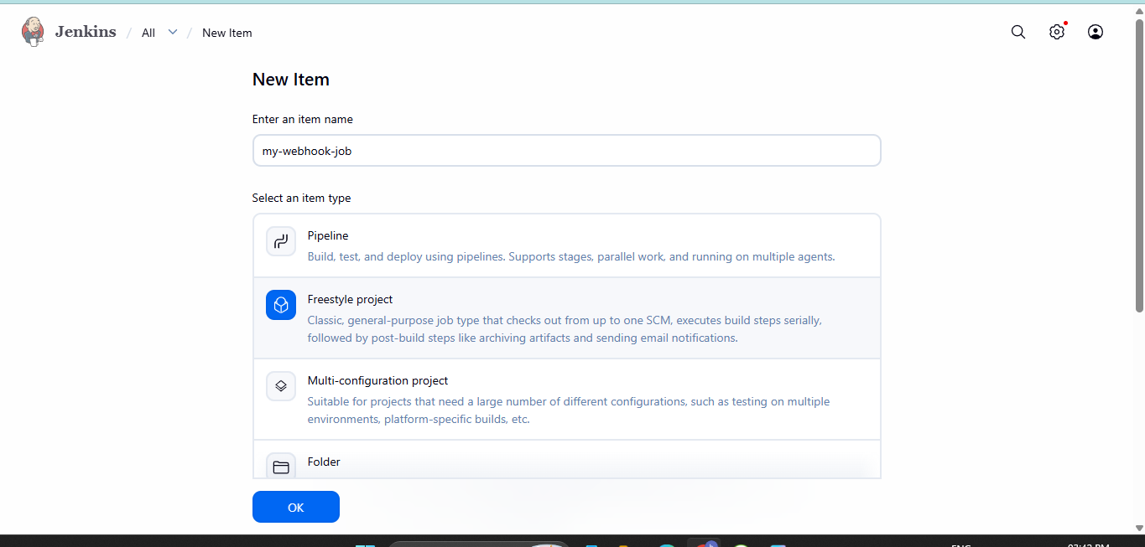

Configure poll SCM
Open Your Jenkins JobOpen Configure PageBuild TriggersEnable Poll SCMAdd Poll SCM Schedule
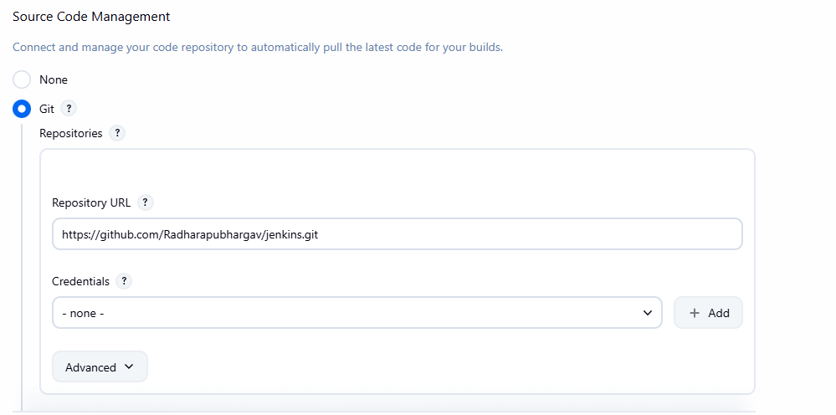

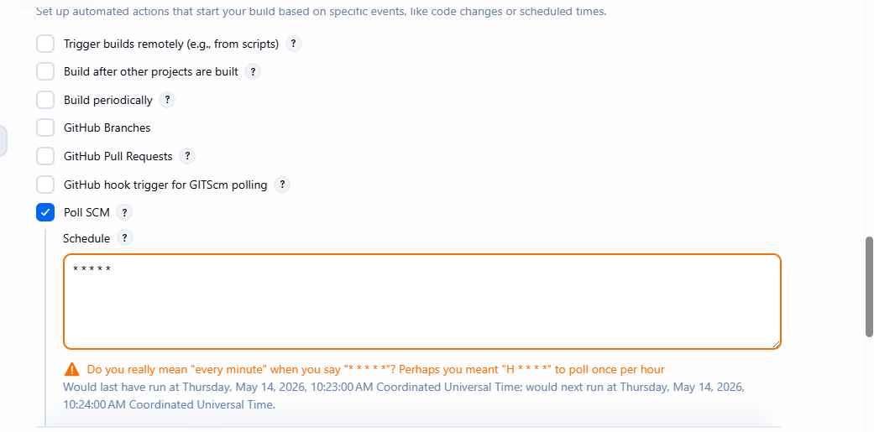

Test pollscm
Make changes in GitHub repository.
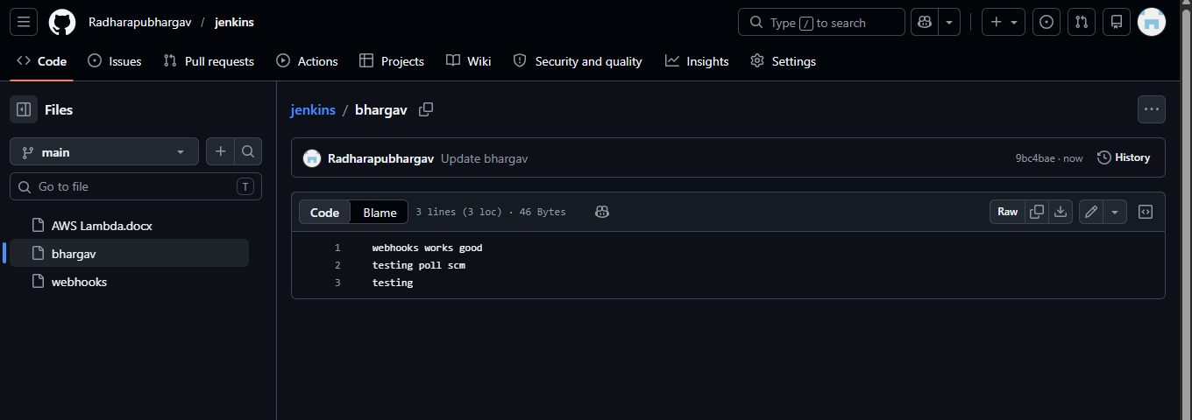
Jenkins should automatically trigger a build.
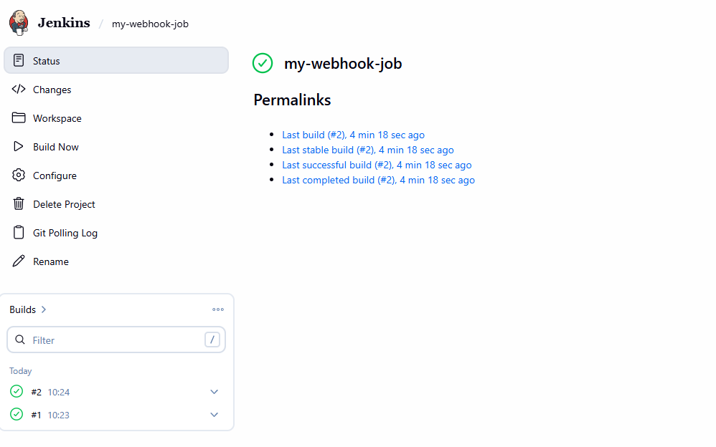

Configure Build Periodically
Job → ConfigureEnable Build PeriodicallyAdd ScheduleSave Configuration
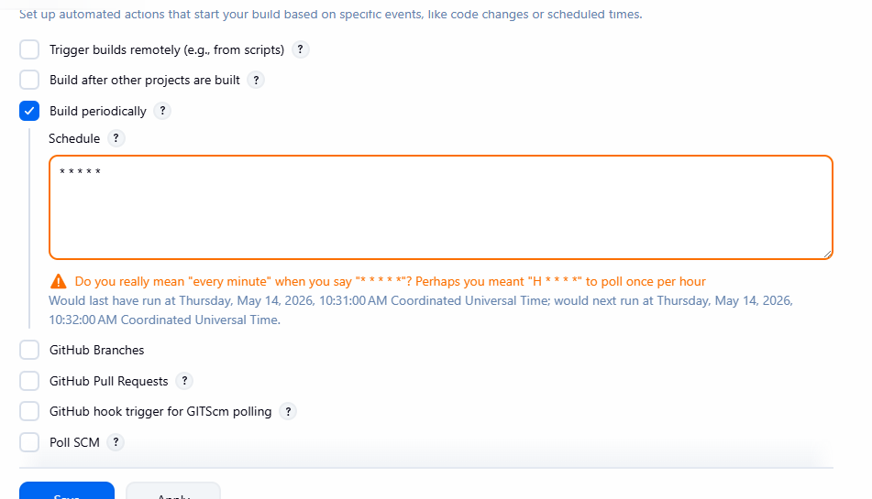
At scheduled time Jenkins automatically starts build even if no code changes exist
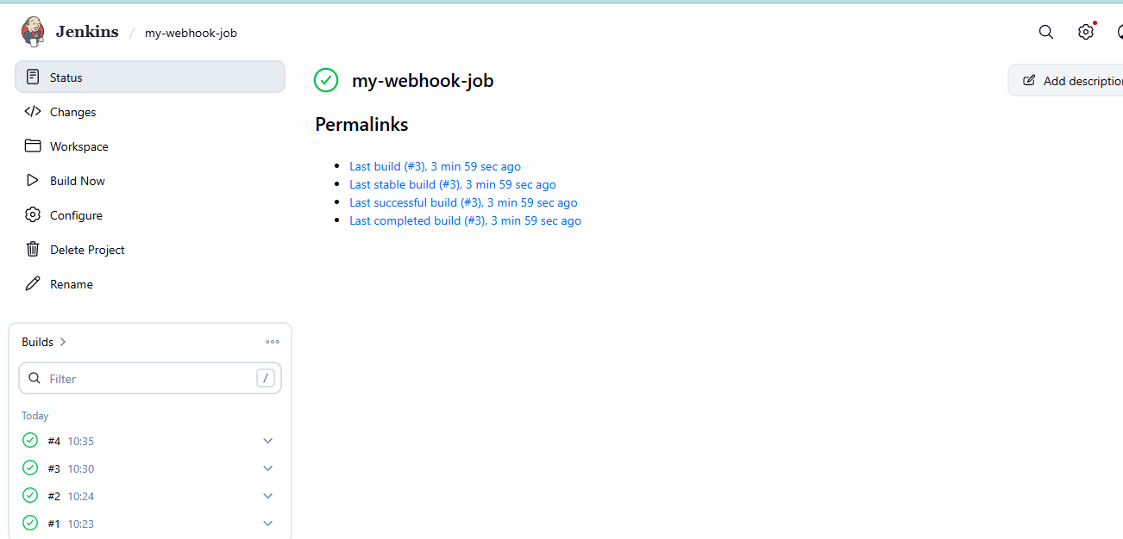

Use Poll SCM when:
- You want automatic builds after commits
- Webhooks are unavailable
Use Build Periodically when:
- Running backups
- Cleanup jobs
- Nightly testing
- Scheduled deployments

- Take a backup of the Jenkins server using abash-script.
Create Backup Directory
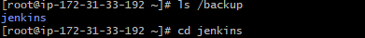
Create Backup Script FileAdd Backup Script Content
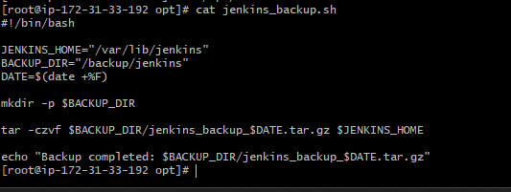
Save the FileGive Execute PermissionRun Script Manually
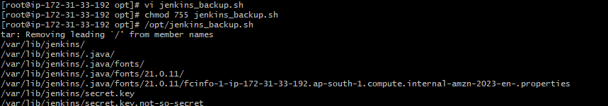
Verify Backup Created
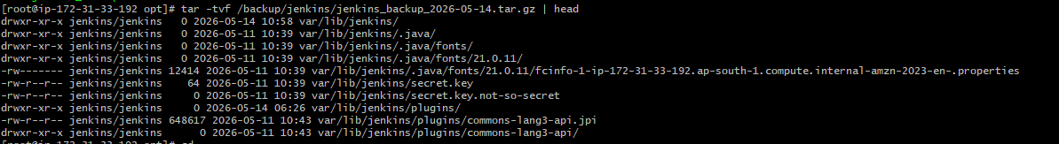
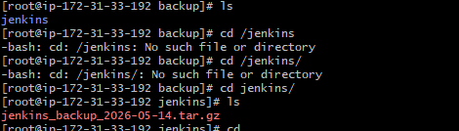

- Take a backup of Jenkins using theThinBackupplugin.
Manage Jenkins → PluginsInstall Plugin
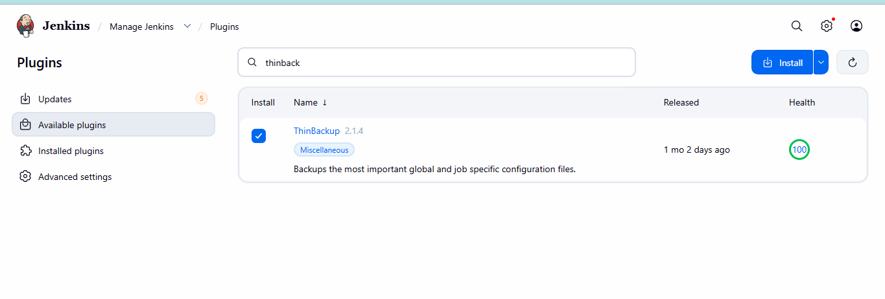
Open ThinBackup ConfigurationConfigure Backup Directory
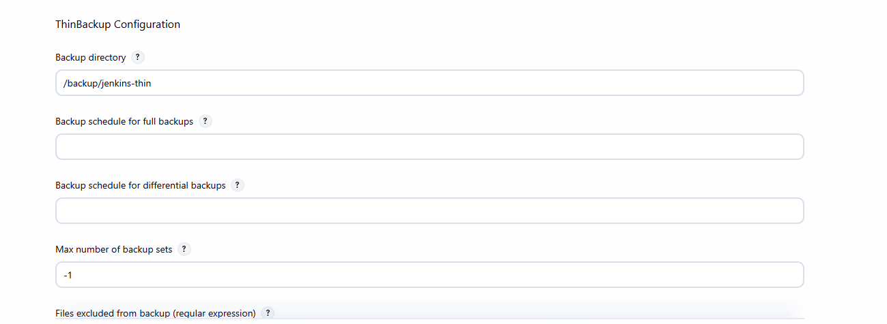
Create Backup Directory on ServerGive permissions
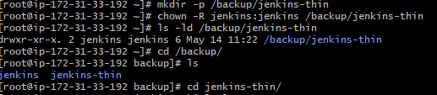

Click on backup now
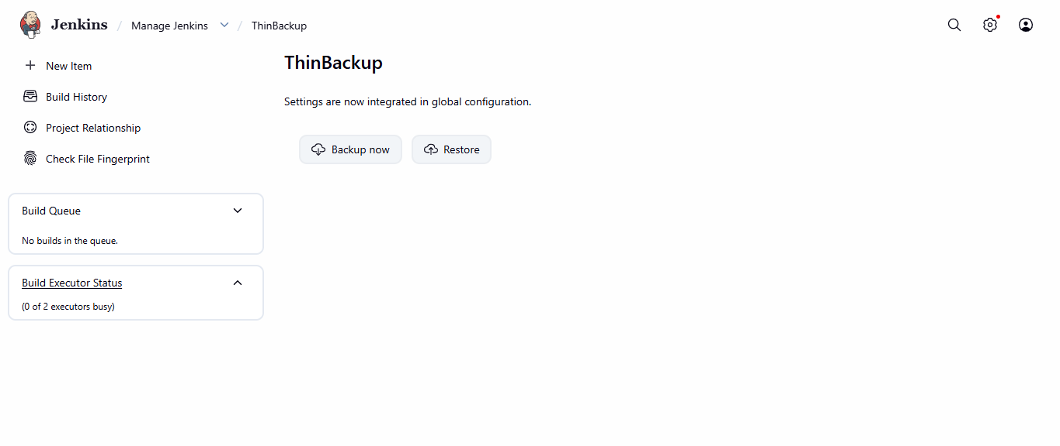
Verify
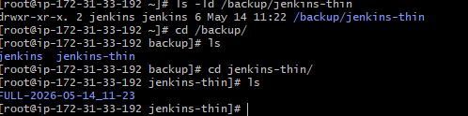



- Set up a new Jenkins server and restore the backup taken in task 4.

Create new instances install java install jenkins
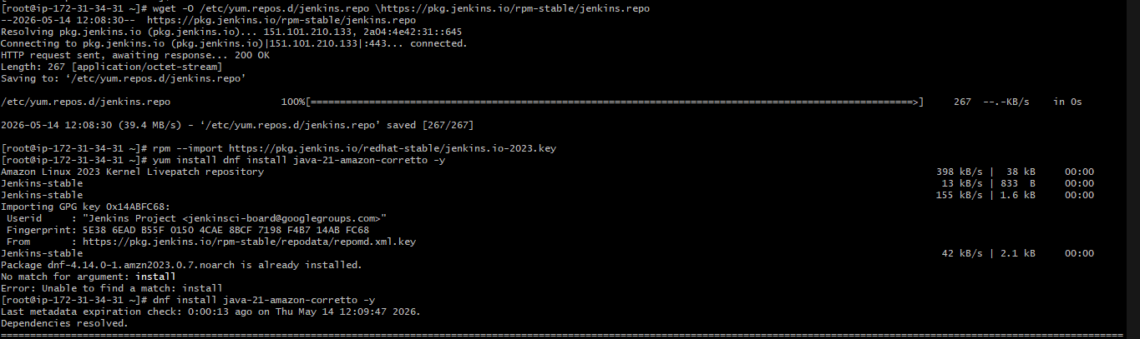

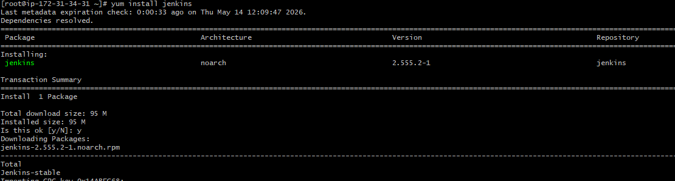

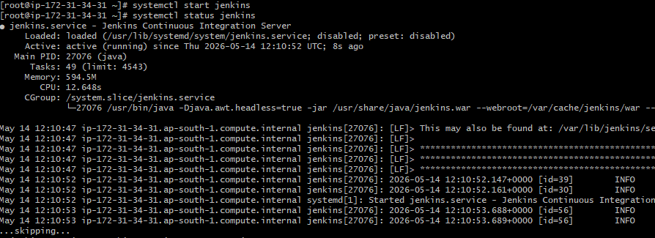
By using scp command backup file transfer to new server
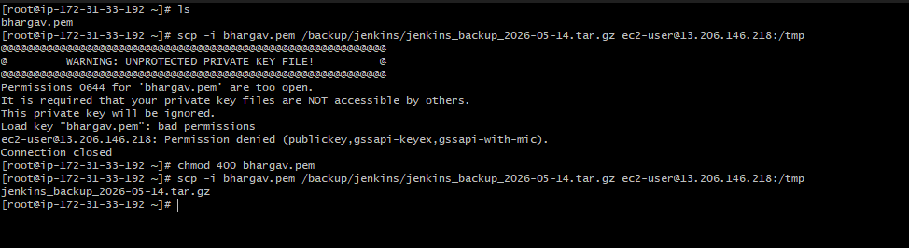

Copy tar file to tmp folder to Jenkins folder
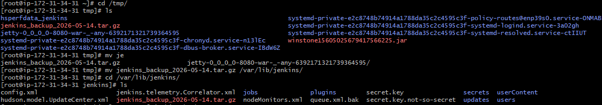
Extract file
